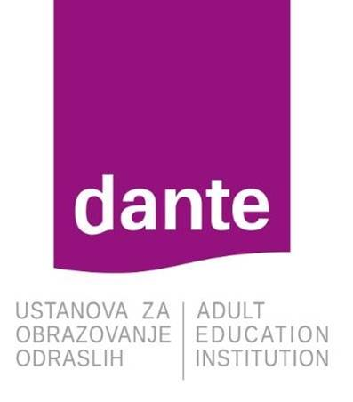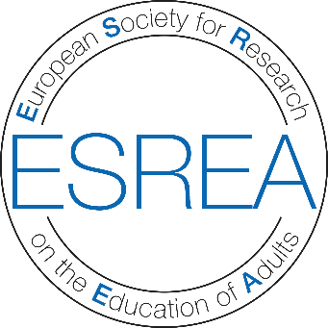

Education 2030 & Adult Learning: Global Perspectives and Local Communities - Bridges or Gaps? Agendas, praxis and research.

Opatija, Croatia
7-10 June 2018

Conference website:
http://www.dante-ri.hr/

Organised by:
ESREA network Between Global and Local: Adult Learning and Communities and the Adult Education Institution Dante
ESREA Research Network
Between Global and Local: Adult Learning and Communities

It is our pleasure to invite you to the 10th ESREA Conference of the Between Global and Local: Adult Learning and Communities (BGL-ALC) Network titled Education 2030 & Adult Learning: Global Perspectives and Local Communities - Bridges or Gaps? Agendas, praxis and research., that will be held in Opatija, Croatia from 7 to 10 June 2018.

THE BGL-ALC NETWORK
The BGL-ALC Network was established in 2006 to bring together European researchers committed to studying community development and adult learning. We believe that the social life of people in communities is a key element for understanding adult learning. In order to clearly identify global and regional/local dimensions of adult learning processes and social change, different scales of community development need to be analysed together.
Our aim was to create a network capable of encouraging research on development in the context of globalisation by using territorial and micro-scale approaches, urban and rural studies, studies of community regeneration, and locating learning places and spaces. All of these issues hinge on the centrality of adult learning in the processes of community development.

THE CONFERENCE THEME
SDGs for Education
In September 2015, UN member countries adopted a set of goals to end poverty, protect the planet, and ensure prosperity for all as part of the 2030 Agenda for Sustainable Development. Each of the 17 Sustainable Development Goals (SDGs) has specific targets to be achieved in a 15-year period.

The 2030 Agenda highlights education as a stand-alone goal (SDG 4), committed to providing inclusive and equitable quality education at all levels. Education is also included under several other SDGs, specifically those on health; growth and employment; sustainable consumption and production; and climate change. Education is therefore seen as a necessary precondition and key element in the achievement of the abovementioned goals. The overarching aim of SDG 4 is to provide comprehensive, holistic, and universal education that transforms the lives of individuals, communities and societies, leaving no one behind.

The Network and SDGs
The task of achieving the Education 2030 goals embodies elements central to the research and work of the BGL-ALC Network. The 2030 Agenda stresses the vital and beneficial role of learning and education in communities and societies, recognising that learning is imperative for achieving sustainable development, equity, and inclusion.
The 2030 Agenda is faced with a considerable challenge in bridging the gap between the global and the local to ensure attainment of specified goals for accelerated progress. By signing the document, governments have committed themselves to translate global targets into achievable national targets based on their education priorities, national development strategies and plans, the ways their education systems are organised, their institutional capacity and the availability of resources. National governments, municipalities, towns, cities and regions have a responsibility as policy and decision-makers to address global education and learning goals.
If education and learning SDGs are to be achieved, active participation and collaboration between communities around the world, including all relevant sectors and stakeholders, will be required. While change will be ultimately driven by measures taken by national, regional and local governing institutions, this will need to be supported by eﬀective multi-stakeholder partnerships. Implementing the Agenda will require national, regional and global mechanisms for governance, accountability, coordination, monitoring, follow-up and review, reporting and evaluation. It will also require enabling strategies, including partnerships and fInancing.
We need to create processes that generate engagement with the SDGs at the community level. The goals and targets set out in the 2030 Agenda can only be achieved if members of local communities take responsibility for implementing the SDGs in their own context.
How can we engage communities everywhere to make global goals set by the UN their local goals? How can individuals and collectives contribute to achieving the Agenda 2030 for adult learning?

Possible key topics for contributions (papers, roundtables, keynote talks) to this conference include:

- How can cooperation between stakeholders at national and transnational levels contribute to the development of accessibility, equality and sustainability in adult learning?

- Researching accessibility, equality, and sustainability in the local life-world of adult learners

- Global and local challenges in adult learning. How are points of divergence addressed? The role of the researcher.

- Educators as mediators, implementers and creators of local and global education policies.

- The role of research in interpreting global adult learning needs at a national level

- Researching adult learning in the micro-context: bridging the gap to SDGs?

- National and local communities' readiness to implement global sustainable development goals for adult learning

- Traversing gaps between national policy context and global commitments

- Cross-sector collaboration for a knowledge-based society

- Holistic approaches to adult learning: Connecting agenda, praxis and research

- Flexible adult learning: Who decides when and where to learn?

ABSTRACTS AND PAPERS

Participants from all fields of research on adult learning are invited to submit an abstract addressing the conference theme. Abstracts should be no more than 500 words long.

Abstract submission deadline: 31 January 2018.
The Scientific Committee of this conference is responsible for the selection of submitted abstracts.
Notification of acceptance: 28 February 2018.
Abstracts should be sent in two separate files, one including the paper title, the name, address, e-mail of author(s); and the second one including the paper title and abstract.
Abstracts should be submitted to: esrea.dante@gmail.com.

Papers
Completed papers should be submitted by 15 May 2018 to: esrea.dante@gmail.com.

The papers should be no more than 5000 words long and they should be prepared in accordance with BGL-ALC guidelines, which will be made available soon.

Information for Contributors of Abstracts/Papers
A paper is proposed and submitted in the form of an abstract by one person. Up to three other people can be named as co-authors in the abstract proposal. Each participant can submit a maximum of two proposals in which they are either the author or co-author. The abstract proposal must indicate which of the named authors will be presenting the paper. All those presenting must register for the conference.

Criteria for Review of Abstracts
Abstracts for papers are welcome from all fields of research addressing the conference theme. The criteria used in reviewing each abstract are as follows:
- Proposals should be directly related to the conference theme
- Proposals should make reference to a theoretical framework, involve systematic enquiry of analytical or empirical nature
- Background, method, results and implications should be set out clearly in a manner accessible to an international audience

Language
The abstract, the paper and its presentation should be in English. Simultaneous translation will not be available in plenary or paper presentation sessions, but participants will aid one another where necessary in order to overcome language difficulties.
Please bear in mind when presenting a paper that you are speaking to an international audience, the majority of whom may not be familiar with your own country let alone its adult education system. Please avoid the use of acronyms and do not use context-dependant expressions related to adult learning.

Deadlines
Submission of abstracts – 31 January 2018
Acceptance of paper proposals – 28 February 2018
Submission of full papers – 15 May 2018

REGISTRATION

 | Early Bird Registration – before 15 April 2018 | Late Registration –  from 15 April to 18 May 2018
ESREA members | 130 EUR | 160 EUR
Non-members | 180 EUR | 210 EUR
PhD students | 60 EUR | 100 EUR

Conference Fee
The conference fee will include conference materials, coffee breaks during the conference, and lunch on Friday and Saturday.
The cost of the conference dinner – venue to be announced – is separate from the conference fee.

Student Bursaries
As a way to support graduate students’ participation in the conference, three bursaries will be awarded to graduate students (PhD and MA students). The applicant’s institution/university should be a member of ESREA and the applicant has to submit a proposal for the conference.
The bursary is 300 EUR per person and should be used for travel and/or accommodation costs only.
Applications should be first submitted no later than 15 April 2018 to: esrea.dante@gmail.com.
Questions regarding the application procedure should be directed to Robert Aman, the secretary of ESREA (robert.aman@liu.se).

CONTACT

Scientific Committee
Ewa Kurantowicz (Wroclaw), Emilio Lucio-Villegas (Seville), Rob Evans (Magdeburg), Katarina Popović (Belgrade), Marijeta Mašić (Rijeka), Siniša Smiljanić (Rijeka)

Organising Committee
Rob Evans, Ewa Kurantowicz, Emilio Lucio-Villegas, Andrej Marušić, Petra Katana, Antonela Marjanušić

Conference website
http://www.dante-ri.hr/

