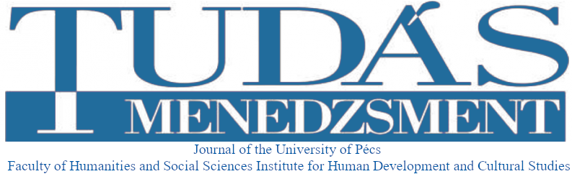

Call for publications in the 2023 English-German language special issue of the Journal Tudásmenedzsment

Tudásmenedzsment (Knowledge Management) is a peer-reviewed journal of the Faculty of Humanities and Social Sciences University of Pécs, which offers publications in the following fields of humanities and social sciences:
- cultural studies; cultural theory; activities of cultural institutions and organizations
- cultural policy and cultural management
- cultural economics
- community organization and community development
- sociology of culture, sociology of education
- pedagogical psychology, work psychology, organizational psychology, art psychology
- community philosophy, cultural philosophy, educational philosophy
- cultural history, history of education
- educational science (pedagogy, andragogy, gerontagogy)
- education policy/ law, educational administration, economics of education
- vocational and adult training
- human resource management and the labor market
- company-level research in human resource management

The journal Tudásmenedzsment is published twice a year in Hungarian language. The journal publishes an English-German language special issue once a year.

The editorial board of Tudásmenedzsment is calling for publications for the 2023 English-German language special issue below:

Cross-cultural resilience building

Submission of manuscripts due 15 January 2023

In addition to its own website, Tudásmenedzsment also appears in the Open Journal System (OJS).
Websites:
http://btk.pte.hu/hu/hfmi/tudasmenedzsment
https://journals.lib.pte.hu/index.php/tm

Formal requirements and other information
We ask our authors to prepare their papers in a minimum of 25,000 and a maximum of 40,000 characters based on the publication template that can be downloaded from the website. The specified number of characters does not include spaces.
Reference style: APA
Manuscript submission: tudasmenedzsment@pte.hu

In connection with the studies, please submit an abstract in accordance with the requirements of the given template. Abstract length: minimum 1200 characters, maximum 1500 characters (without spaces).
We also ask our authors to submit their short introductions in English (Name, academic degree, position, institution, list of research areas, e-mail address)
The manuscripts submitted to Tudásmenedzsment journal must be unpublished.
Publication in the journal is free of charge.

Peer-review process
The journal Tudásmenedzsment publishes articles after double-blind peer reviews. The submitted articles are primarily reviewed by the members of the editorial board, but external reviewers are also involved optionally. In all cases, the papers are reviewed by experts of the particular field.
The review process takes one month. Reviews are sent to the author (only to the first author in the case of multiple authors) electronically without indicating the names of the reviewers.
The submitted paper will be published in the journal in case of two positive reviews, following the author's revision requested by the reviewers. If a negative and a positive review are received in connection with the article, the editorial board will decide on the publication and the necessary modifications. If both reviewers suggest rejecting the writing, the editorial board refuses to publish the paper.
By submitting the publication to the journal, the author agrees that the Tudásmenedzsment journal will publish the article on its website, in the OJS system, as well as on other professional and scientific websites (eg. MTMT).

